Infoblox Service Instance Architecture & Service Comparison Overview

Topic | Integrated - Single Service Instance | Dedicated - Dual Service Instances
 | 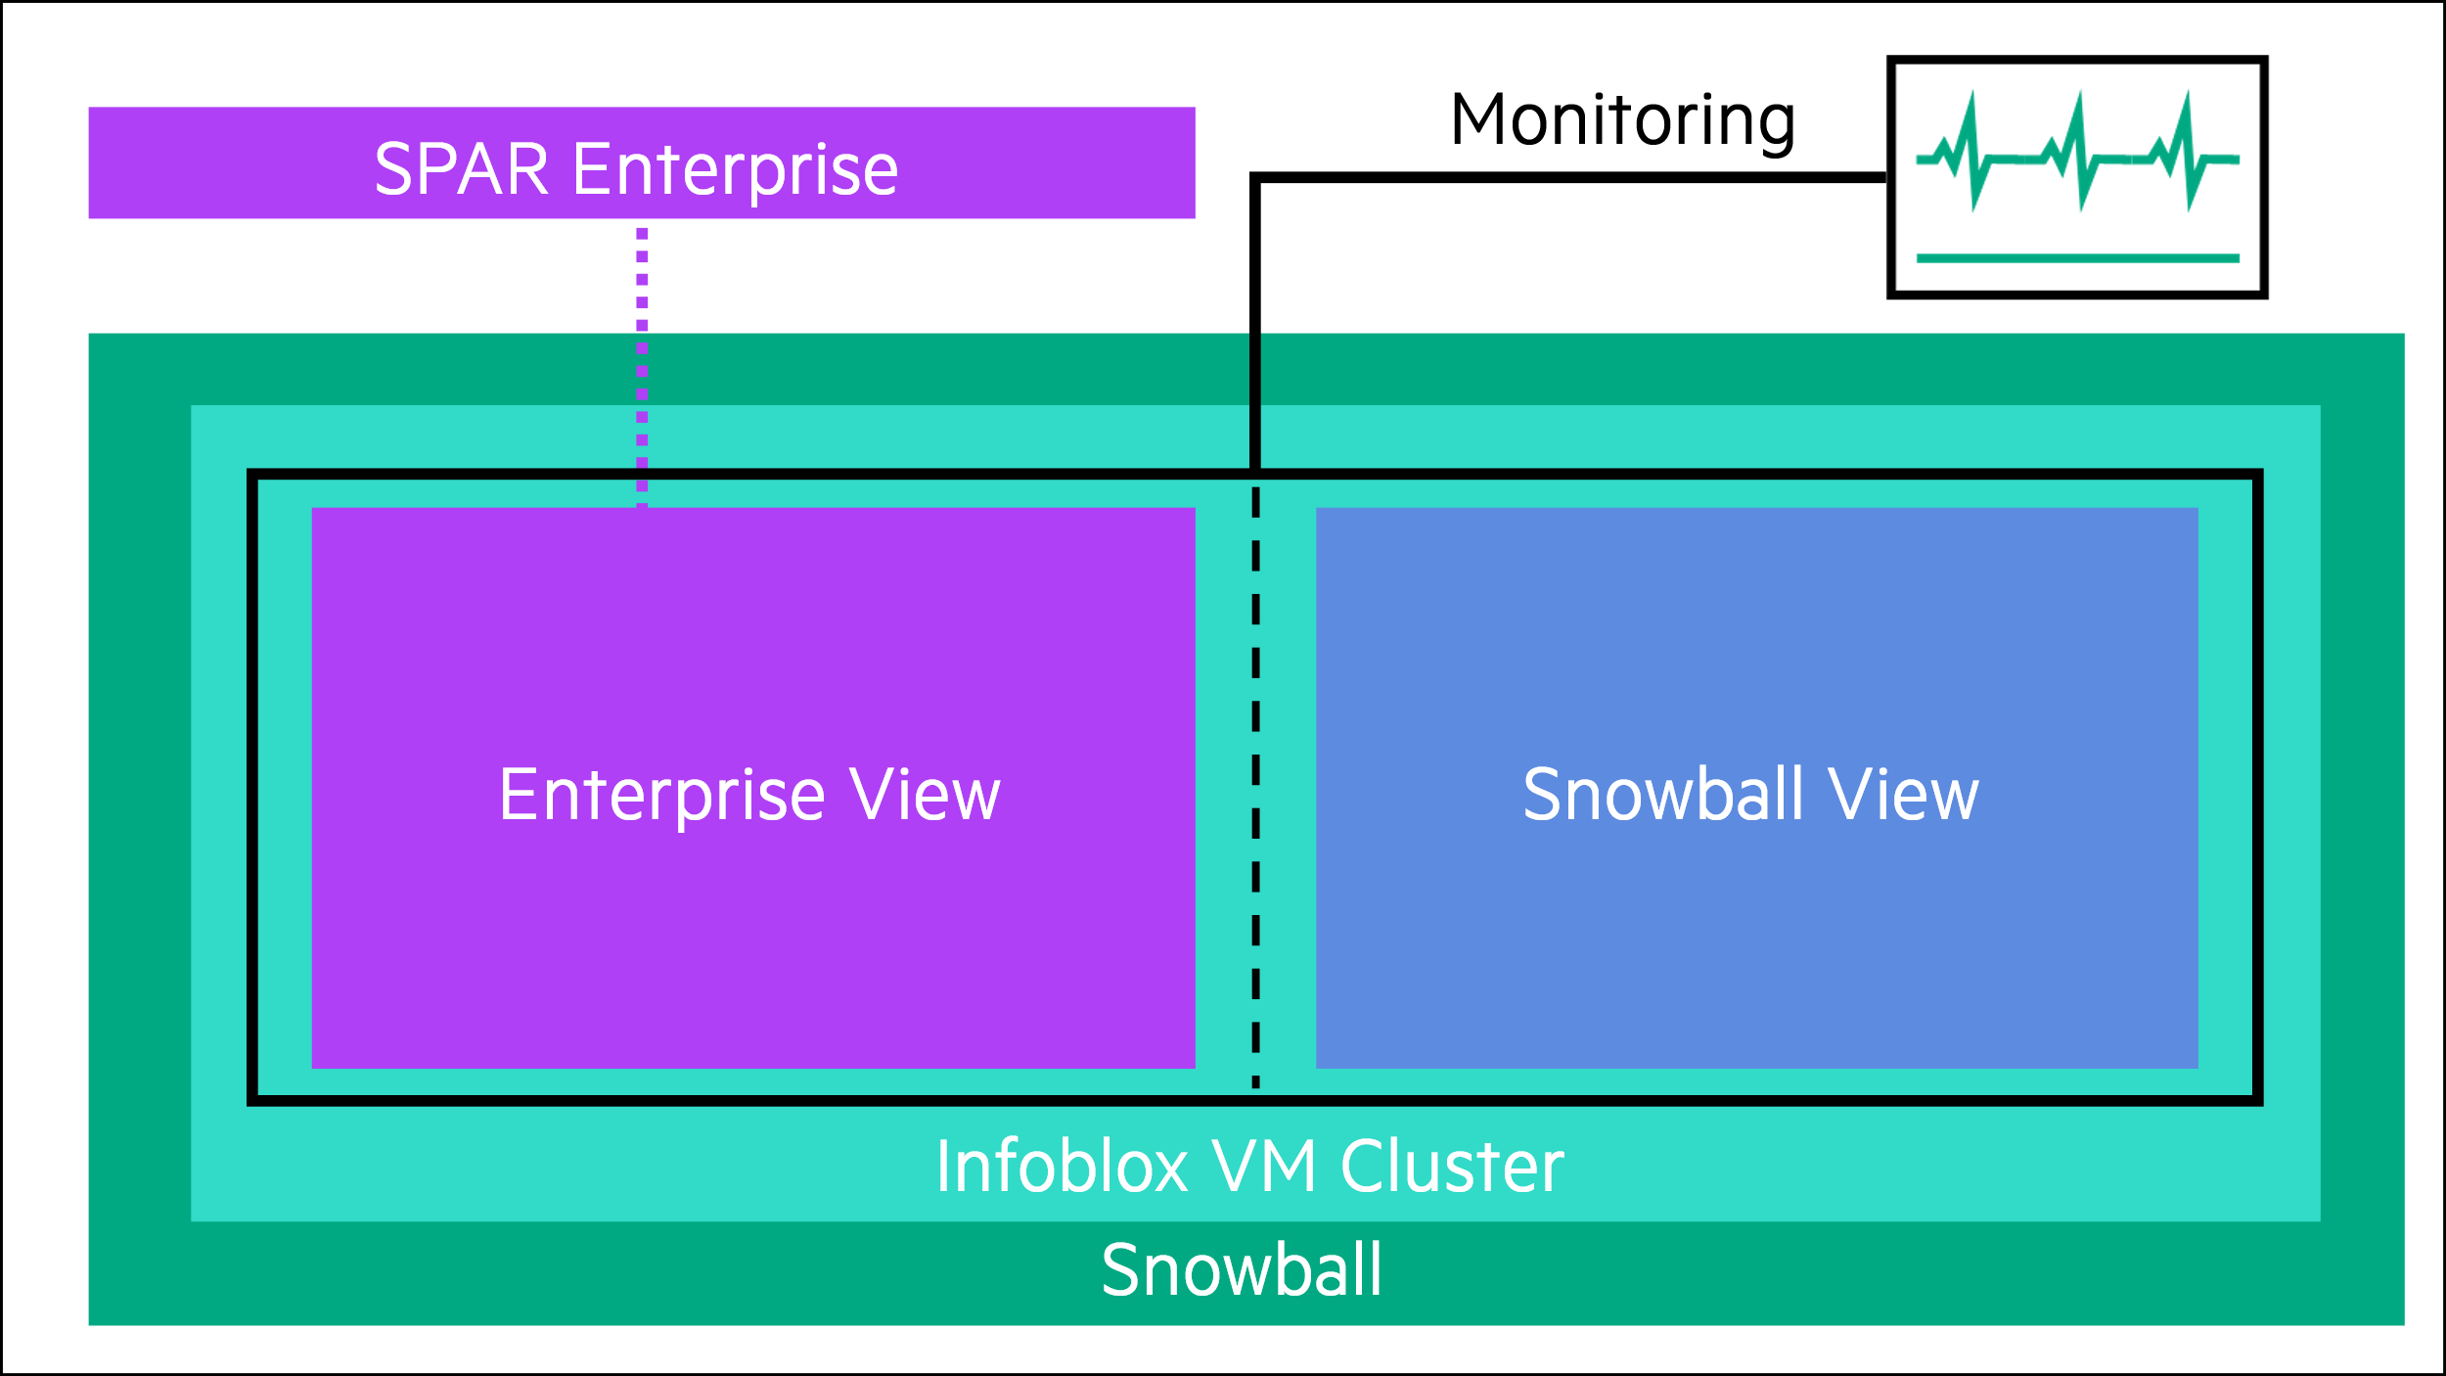 | 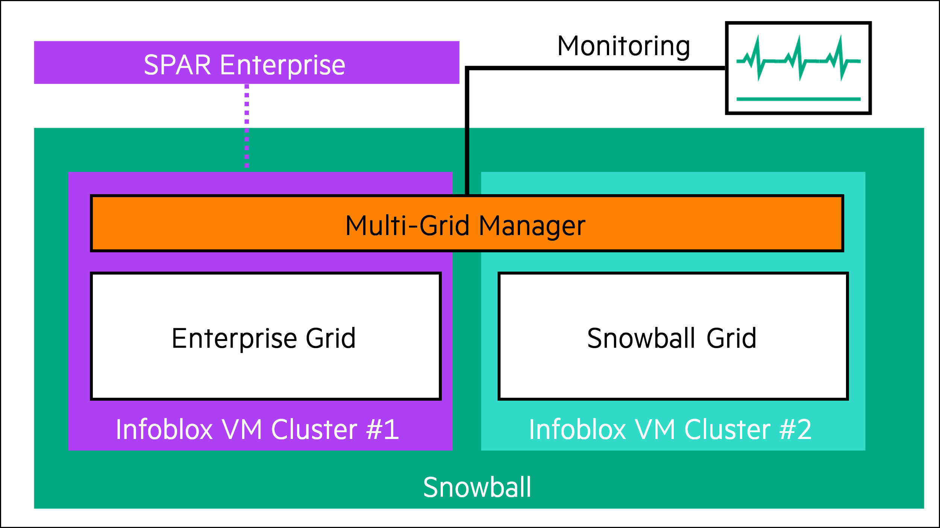
Structure of environment | One Infoblox deployment with logical partitioning (=views)  Shared resources and performance  Complex configuration management | Separate Infoblox clusters hosted on Snowball platform  Isolated resources and performance  Independent configuration management
Separation | Out-of-the box only logical separation available with limited multi-tenant capabilities  HPE must implement a robust, granular permissions model, with SPAR clearly defining technical requirements to enable HPE to build and validate specific roles. This requires significant upfront collaboration from SPAR | Strict isolation by design
Responsibilities | HPE  Platform & Infoblox instance availability/patching  Overall system configuration & security  Backup & Disaster Recovery of the entire instance  Defining and maintaining logical separation (views, permissions) | HPE  Availability of the underlying hosting platform (VMs)  Initial deployment of both Infoblox instances  Snowball View: Full management (patching, security, backup, disaster recovery)  Enterprise View: Offer tiered management
 | SPAR  Manage all DDI records (DNS, DHCP, IPAM) within their assigned logical view  Administer own users within the permissions granted by HPE  All IT systems and network configurations outside SNOWBALL | SPAR  Manage all DDI records (DNS, DHCP, IPAM) within Infoblox Enterprise instance  Administer SPAR users within Infoblox Enterprise instance  All IT systems and network configurations outside SNOWBALL
Rights | HPE  Full, unrestricted administrative access  Set and enforce configuration standards  Perform maintenance according to HPE standards | HPE  Full, unrestricted administrative access  Offer different service levels for Enterprise instance
 | SPAR  Access and manage Enterprise view  Receive service health reports | SPAR  Access and manage Enterprise instance  Receive service health reports  Choose the level of management service from HPE for Enterprise instance
Duties | HPE  Ensure logical separation is effective and secure  Provide SPAR with contractually defined administrative roles  Fulfill Service Level Agreements (SLAs) for the entire instance | HPE  Ensure strict network and resource isolation  Deliver platform-level SLAs for virtual machines  Clearly define the support boundary for Enterprise instance
 | SPAR  Operate exclusively within the granted permissions  Report any service anomalies or issues to HPE promptly  Ensure configurations do not violate HPE's policies  Continued collaboration to ensure HPE fulfills its responsibilities for the shared Infoblox instance supporting Snowball operations | SPAR  Grant HPE specific administrative rights to Enterprise instance and agree on patching schedules, backup policies, and response times, distinct from the underlying SNOWBALL SLA  Manage Enterprise instance's configuration and security  Ensure no configuration on Enterprise instance impacts Snowball
Access Rights | Shared admin access with role-based views  HPE maintains platform segregation controls  Risk of privilege escalation between views  Single authentication system | Dedicated admin access per instance  Clear ownership boundaries  HPE retains infrastructure access to VMs  Separate authentication possible
Subscription Provisioning | Infoblox subscriptions through HPE, underlaying services through Snowball MSA
Infoblox Subscription costs | Largely neutral due to total number of managed objects / queries being the main cost driver  Current Infoblox service on Snowball would needs to be up-licensed massively |  | Largely neutral due to total number of managed objects / queries being the main cost driver
Resource costs | VM resources-efficient due to shared infrastructure | higher VM costs
Legal | New Service Introduction process and change request to embed it into Snowball MSA
Self Service Capabilities | Parallel project to the New Service Introduction process
Support Structure | Complex shared responsibility model  Troubleshooting requires coordination | Easier to isolate support responsibilities
Monitoring | Unified monitoring with filtered views  Shared alerting infrastructure  Complex threshold management  Single dashboard with role-based access | Separate monitoring stacks possible  Independent alerting per instance  Clear SLA boundaries  Dedicated dashboards per responsibility

